N+ - Network Security, Maintenance and Troubleshooting Procedures

Build a SOHO Network :

Q1. Draw a network diagram for a small office/home office (SOHO) setup that includes: one broadband internet connection, one Wi-Fi router, two laptops, one smart TV, and one printer. Clearly label each device and connection type (wired or wireless).
Ans:
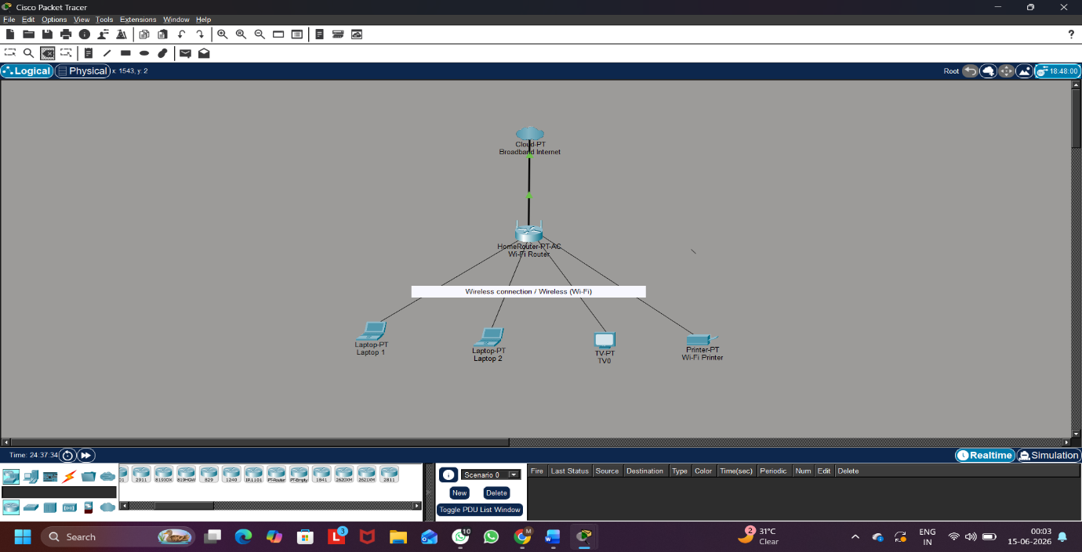
Figure 1: small office/home office (SOHO) setup in Cisco Packet Tracer

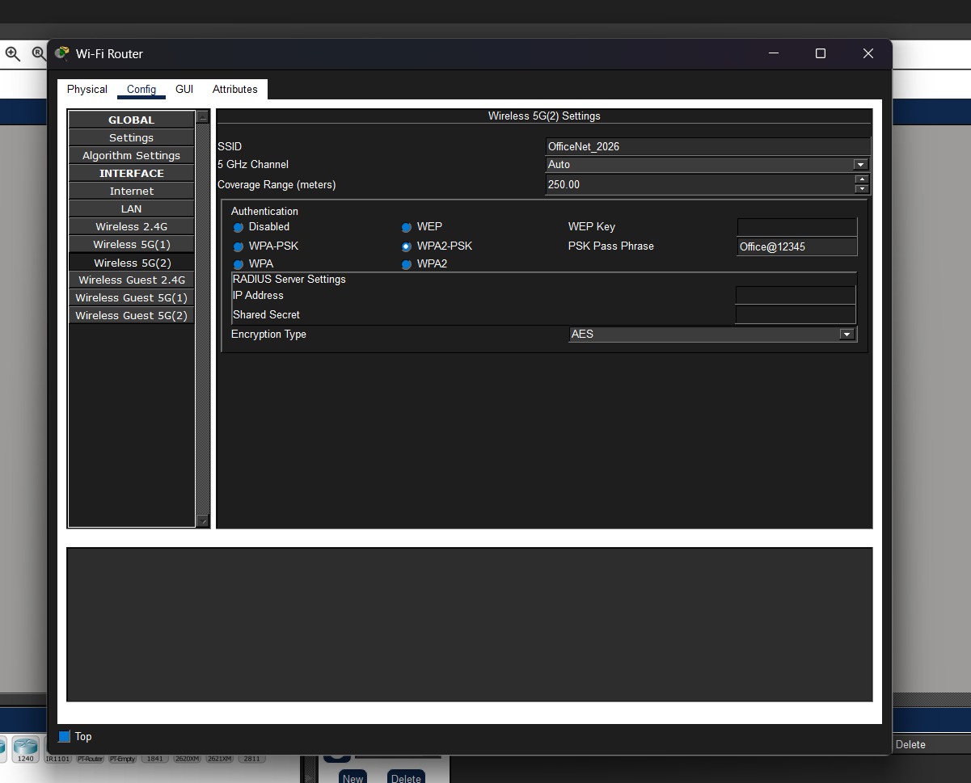
Figure 2: Wi-Fi Router Configuration Settings

Connection Types:
Connection | Type
Broadband Internet → Wi-Fi Router | Wired (Ethernet Cable)
Wi-Fi Router → Laptop 1 | Wireless (Wi-Fi)
Wi-Fi Router → Laptop 2 | Wireless (Wi-Fi)
Wi-Fi Router → Smart TV | Wireless (Wi-Fi)
Wi-Fi Router → Wi-Fi Printer | Wireless (Wi-Fi)

Q2. List all the hardware components (with brand/model suggestions) you would need to physically build the SOHO network diagrammed above, including cables and any switches or extenders if needed.<br><br><em><strong>Hint:</strong> Check current listings on Flipkart or Amazon for typical device models used in Indian homes/offices.</em>
Ans:
Sr. No. | Hardware Component | Suggested Brand/Model | Purpose
1 | Broadband Internet Connection | JioFiber / Airtel Xstream Fiber | Provides Internet access
2 | Wi-Fi Router | TP-Link Archer C6 | Connects all devices and provides Wi-Fi
3 | Laptop 1 | HP 15s Laptop | User device for network access
4 | Laptop 2 | Dell Inspiron 15 | User device for network access
5 | Smart TV | Samsung Crystal UHD Smart TV | Streaming and entertainment
6 | Printer | HP DeskJet 2820 Wi-Fi Printer | Printing documents
7 | Ethernet Cable | Cat6 Ethernet Cable | Connects broadband to router
8 | Power Adapter | Supplied with Devices | Powers network devices

Steps to Physically Build the SOHO Network:
- Place the broadband modem and Wi-Fi router in a central location.
- Connect the broadband internet cable to the WAN/Internet port of the Wi-Fi router using a Cat6 Ethernet cable.
- Connect the router to a power source and switch it ON.
- Turn ON the laptops, smart TV, and Wi-Fi printer.
- Search for the router's Wi-Fi network (SSID) on each device.
- Enter the Wi-Fi password and connect all devices to the network.
- Verify that all devices can access the internet and communicate through the router.

Q3. Write step-by-step instructions to configure the Wi-Fi router for your SOHO network, including setting up a unique SSID, enabling WPA2 security, and changing the default admin password.
Ans:
Steps to Configure the Wi-Fi Router:
Step 1: Connect the Router
- Connect the broadband internet cable to the WAN/Internet port of the router.
- Connect the power adapter and switch ON the router.
- Connect a laptop to the router.
Step 2: Access the Router Settings
- Open a web browser.
- Enter the router IP address (192.168.1.1).
- Log in using the default username and password.
Step 3: Configure a Unique SSID
- Open the Wireless Settings page.
- Locate the SSID field.
- Enter a unique network name such as OfficeNet_2026.
- Click Save.
Step 4: Enable WPA2 Security
- Open the Wireless Security page.
- Select WPA2-PSK as the security mode.
- Enter a strong Wi-Fi password such as Office@12345.
- Click Save.
Step 5: Change the Default Administrator Password
- Open the Administration or Management page.
- Select Change Password.
- Enter the current password.
- Enter a new administrator password such as Admin@2026.
- Confirm the new password and click Save.
Step 6: Restart the Router
- Restart the router.
- Reconnect all devices using the new Wi-Fi settings.
- Verify that internet access is working properly.

Result: The Wi-Fi router is successfully configured with a unique SSID, WPA2 security, and a new administrator password.

Q4. Configure IP addresses for all devices in your SOHO network: assign static IPs to the printer and smart TV, and use DHCP for the laptops. Show a table listing each device, its MAC address (make one up), and the assigned IP address.

Ans:

IP Address Configuration

In this SOHO network, static IP addresses are assigned to the Smart TV and Wi-Fi Printer to ensure they always use the same network address. DHCP is enabled for both laptops so that IP addresses are assigned automatically by the router.

Device | MAC Address | IP Address | Assignment Type
Wi-Fi Router | 00:1A:2B:3C:4D:5E | 192.168.1.1 | Static
Laptop 1 | A1:B2:C3:D4:E5:F1 | 192.168.1.100 | DHCP
Laptop 2 | A1:B2:C3:D4:E5:F2 | 192.168.1.101 | DHCP
Smart TV | AA:BB:CC:DD:EE:10 | 192.168.1.20 | Static
Wi-Fi Printer | AA:BB:CC:DD:EE:11 | 192.168.1.30 | Static

Configuration Steps:
For Laptop 1 and Laptop 2 (DHCP):
- Open Network Settings.
- Select Obtain an IP Address Automatically (DHCP).
- The router automatically assigns an available IP address.
For Smart TV (Static IP):
- Open Network Settings.
- Select Manual IP Configuration.
- Enter IP Address: 192.168.1.20
- Enter Subnet Mask: 255.255.255.0
- Enter Default Gateway: 192.168.1.1
For Wi-Fi Printer (Static IP):
- Open Network Settings.
- Select Manual IP Configuration.
- Enter IP Address: 192.168.1.30
- Enter Subnet Mask: 255.255.255.0
- Enter Default Gateway: 192.168.1.1
Result
The Smart TV and Wi-Fi Printer are configured with static IP addresses, while Laptop 1 and Laptop 2 receive IP addresses automatically through DHCP. This ensures easy network management and reliable device connectivity.

Q5.Explain how you would troubleshoot if one of the laptops cannot connect to the internet in your SOHO network. List at least 3 possible causes and what steps you would take to diagnose and fix each issue.

Ans:

If one of the laptops cannot connect to the internet, the following troubleshooting steps can be used to identify and fix the problem.
Cause 1: Incorrect Wi-Fi Connection
Diagnosis:
- Check whether the laptop is connected to the correct Wi-Fi network (SSID).
- Verify that the Wi-Fi signal strength is adequate.
Solution:
- Connect the laptop to the correct Wi-Fi network.
- Re-enter the Wi-Fi password if required.
- Move the laptop closer to the router if the signal is weak. \

Cause 2: IP Address Not Assigned Properly
Diagnosis:
- Open Command Prompt and run the ipconfig command.
- Check whether the laptop has received a valid IP address from the router.
Solution:
- Disconnect and reconnect to the Wi-Fi network.
- Run ipconfig /release and ipconfig /renew.
- Ensure that DHCP is enabled on the router.

Cause 3: Router or Internet Connection Failure
Diagnosis:
- Check the router's Internet/WAN indicator light.
- Test internet access on other devices connected to the same network.
Solution:
- Restart the router and modem.
- Check all cable connections.
- Contact the Internet Service Provider (ISP) if the problem persists.

Cause 4: DNS Configuration Issue
Diagnosis:
- Check whether websites fail to open while the network connection appears active.
- Use the ping command to test connectivity.
Solution:
- Configure a valid DNS server such as Google DNS (8.8.8.8 and 8.8.4.4).
- Restart the network connection.

Result
By checking the Wi-Fi connection, IP address configuration, router status, and DNS settings, most internet connectivity issues can be identified and resolved quickly in a SOHO netwo

